How to Create a factory

1. Go to the GameThemedGroup github page and select the template for the game you’ll be working on.
   * Link: <https://github.com/GameThemedGroup>
2. Copy the link for cloning the repository and make sure that you are cloning using HTTPS.

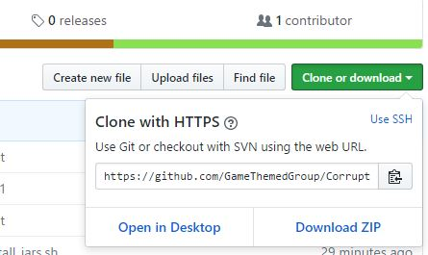

1. Go to your github account and create a new repository. *do not select the checkbox that asks you for initializing with read me
2. Select import code from another repository

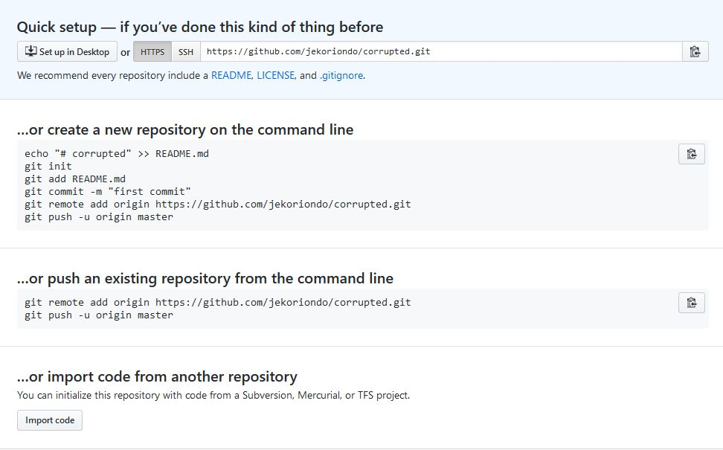

1. Paste the link that you copied from step 2 and begin import.
2. Go to your new repository and copy the link for cloning your repository like what you did from step 2.
3. Go to your codenvy account. Select dashboard > create workspace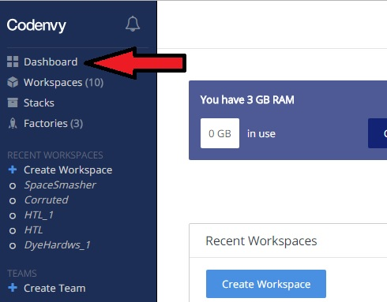
4. Set up the workspace:
   * **Select Source:** Import from existing location
     1. Under Git Repository paste the link that you copied from step 6.
   * **Select Workspace:** create new workspace from stack
     1. select stack authoring
     2. paste this in the text box: FROM codenvy/ubuntu_jdk8_x11
   * **Configure workspace:** 
     1. **Name:** name your workspace e.g. Corrupted
     2. **Ram:** leave it at 2GB
   * **Project Metadata:** 
     1. **Name:** This name must be exactly the same as the Project name or the name of the game.
        + It can only be HTL, DyeHard, SpaceSmasher, or Corrupted
        + 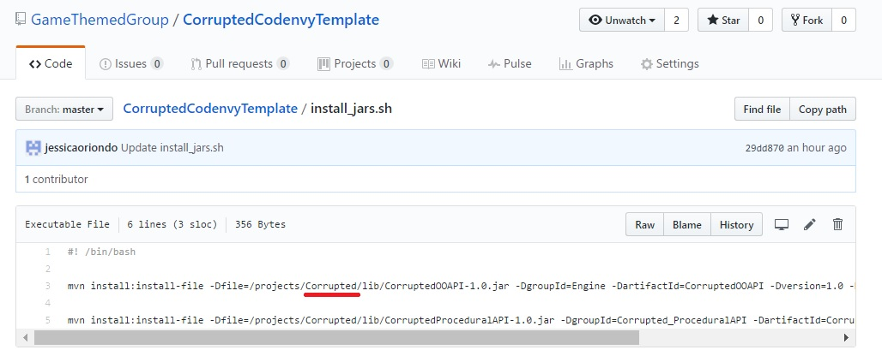Or check it by going through the files on github. Select install_jars.sh and check the project name.
   * Click create.
5. Click the dropdown button for CMD and select edit commands…

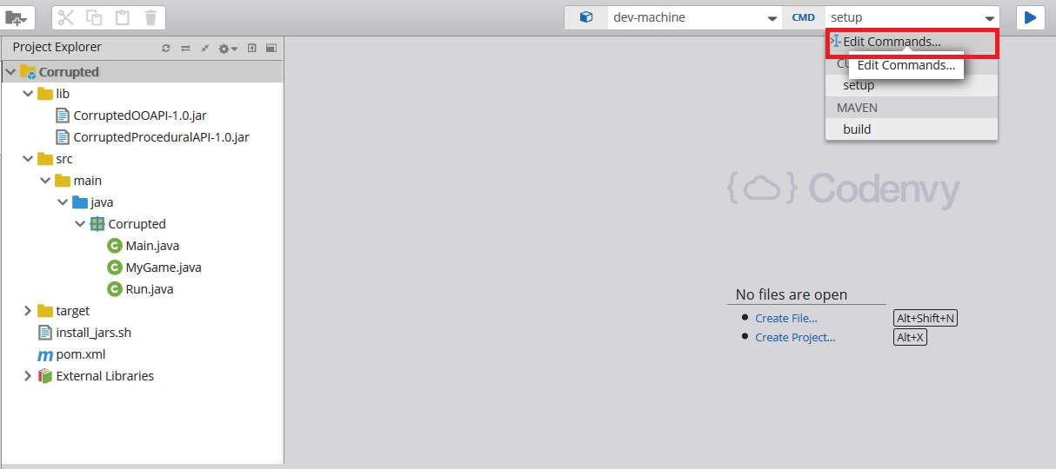

1. Click on the + button for maven
   * Follow this configuration: 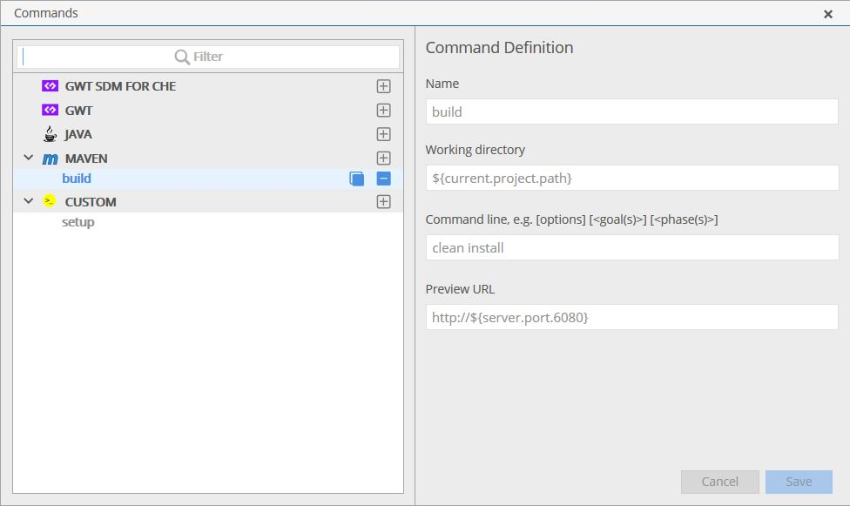
   * save
2. Click on the + button for custom
   * Change the name to setup and put this in the text field under command line:

*make sure to change the highlighted parts.

cat > run.sh ; echo "cd [Project_name]/target ; java -jar [Project_name]-1.0-SNAPSHOT.jar 2> /dev/null" >> run.sh; chmod +x run.sh; cd [Project_name]; chmod +x install_jars.sh;./install_jars.sh

example for Corrupted:

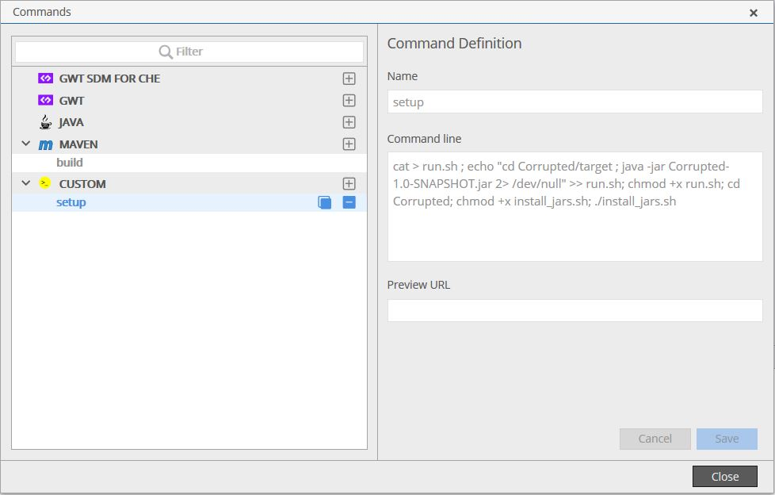

* Save. Close.

1. Run setup command by clicking the blue button.

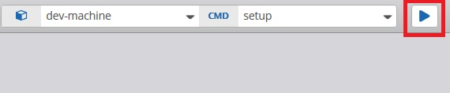

1. Do the same thing with build.

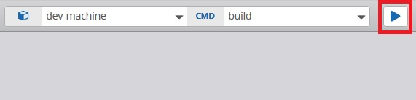

1. Run the program. *if you don’t know how to run the program yet follow the document called run_program_in_codenvy
2. If the program runs, you’re good to code your game.
3. Go to MyGame.java under src/main/java/Corrupted. Edit that file to make your program.

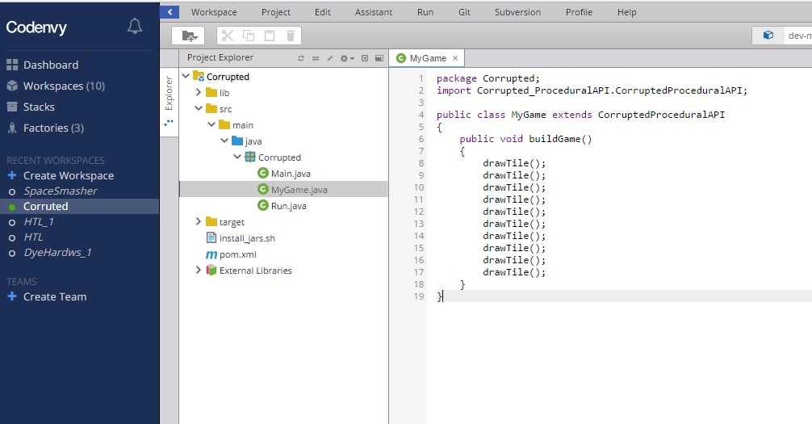

1. After you have created your game. Go to your github account and change the exact file.
   * You can do it by:
     1. downloading MyGame.java from codenvy. (right click on the file and select download)
     2. Select src/main/java/[project_Name] and select upload files.
     3. Upload the file you’ve download and commit changes to github. *It will overwrite the previous file.
2. Go back to your codenvy account and create a factory.
   * Select workspace and click create factory.

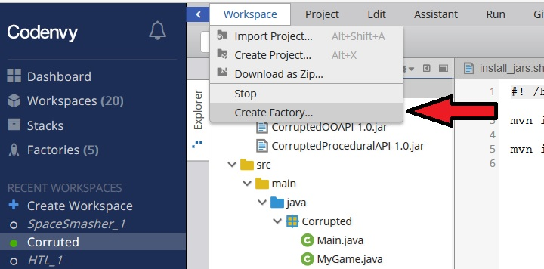

* + You can use any name for your factory.
  + Click create
  + Copy the link provided
  + Distribute the link